**Use case diagrams**

# Use-Case View

A description of the Use-Case View of the system architecture. The Use Case View is important input to the selection of the set of scenarios and/or use cases that are the focus of an iteration. It describes the set of scenarios and/or use cases that represent some significant, central functionality. It also describes the set of scenarios and/or use cases that have a substantial architectural coverage (that exercise many architectural elements) or that stress or illustrate a specific, delicate point of the architecture. The significant use cases (16 Use Cases) in this system are listed below:

* Login
* Logout
* Sign Up
* Display Products
* Display Product Detail
* Display Purchase Order
* Display Selected Product
* Display Order Status
* Choose Product
* Cancel Selected Product
* Order Product
* Cancel Order
* Add Product
* Delete Product
* Edit Product
* Edit Order Status

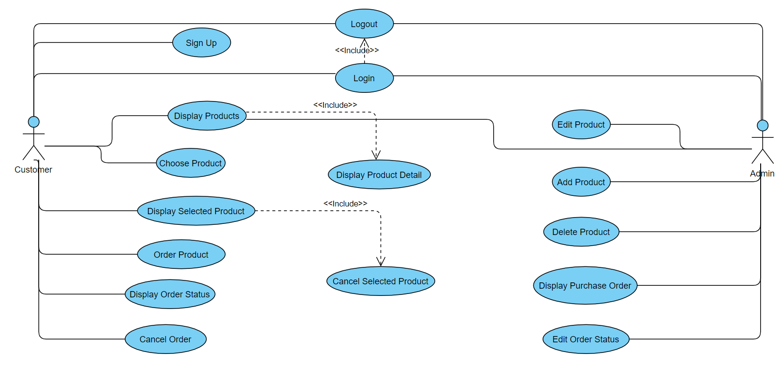

# Use-Case Realizations

**Sign Up:**

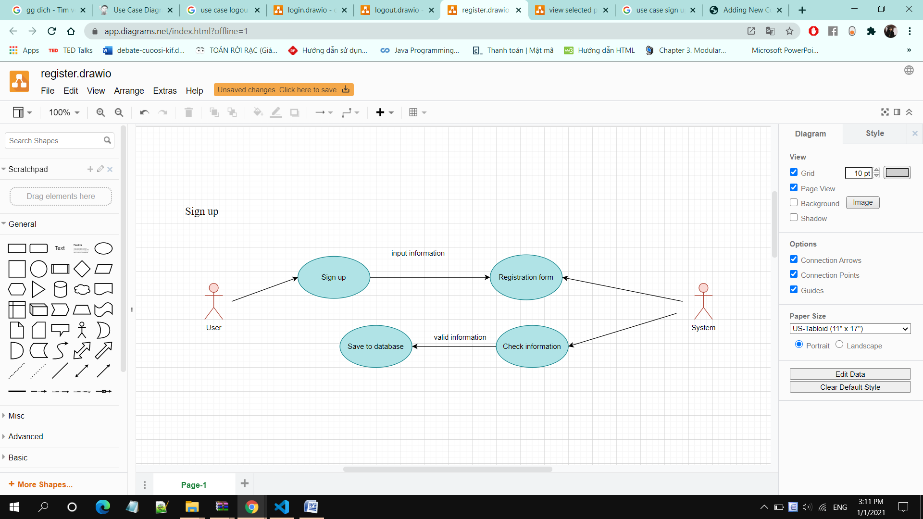

• **Brief Description:** A user creates an account.

**• Specification:** See Use-Case-Realization Specification: Sign Up

**Login:**

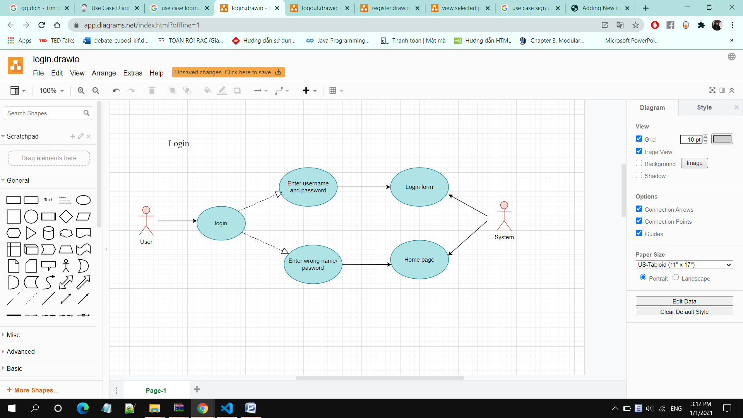

• **Brief Description:** A user logging in to the system.

• **Specification:** See Use-Case-Realization Specification: Login

**Logout:**

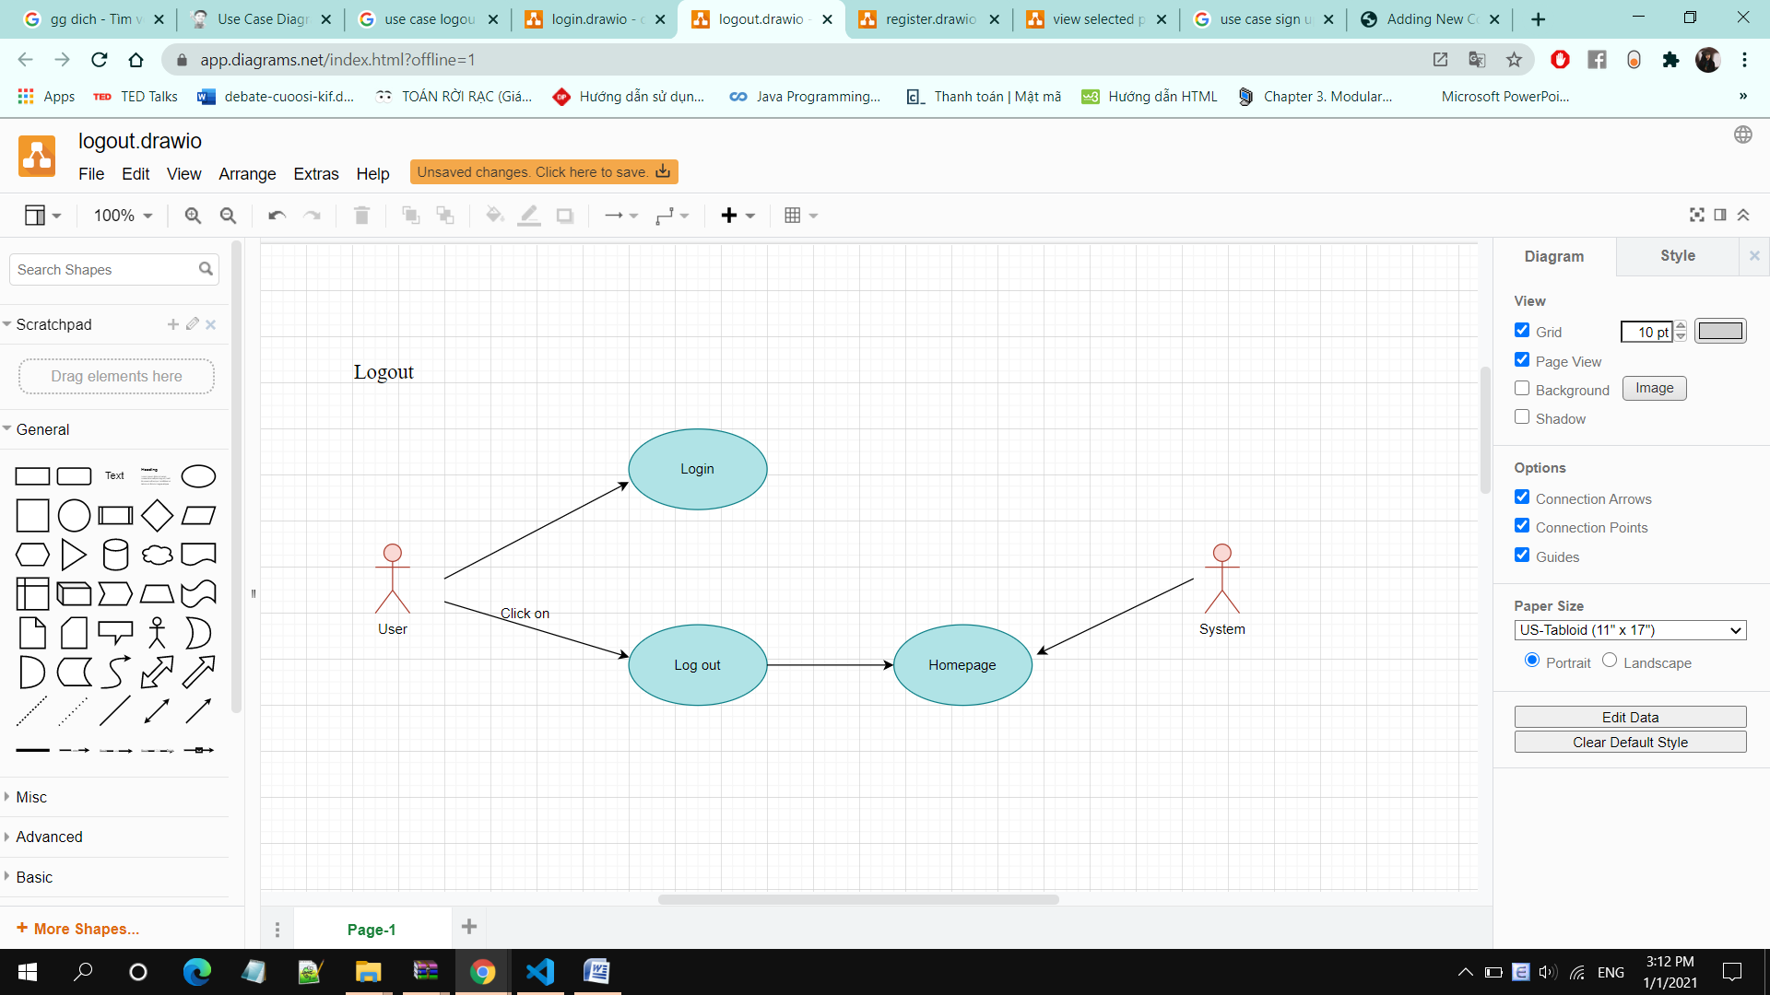

• **Brief Description:** A user logging out the system.

• **Specification:** See Use-Case-Realization Specification: Logout.

**Display Products:**

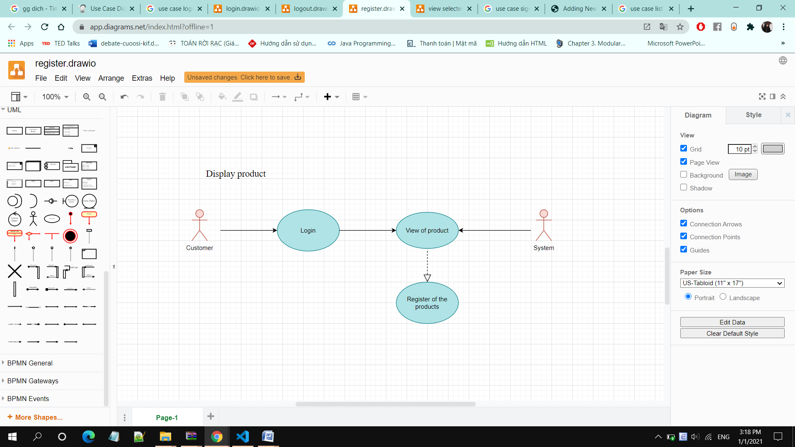

• **Brief Description:** A user displays all available products of the system

• **Specification:** See Use-Case-Realization Specification: Display Products

**Display Product Detail:**

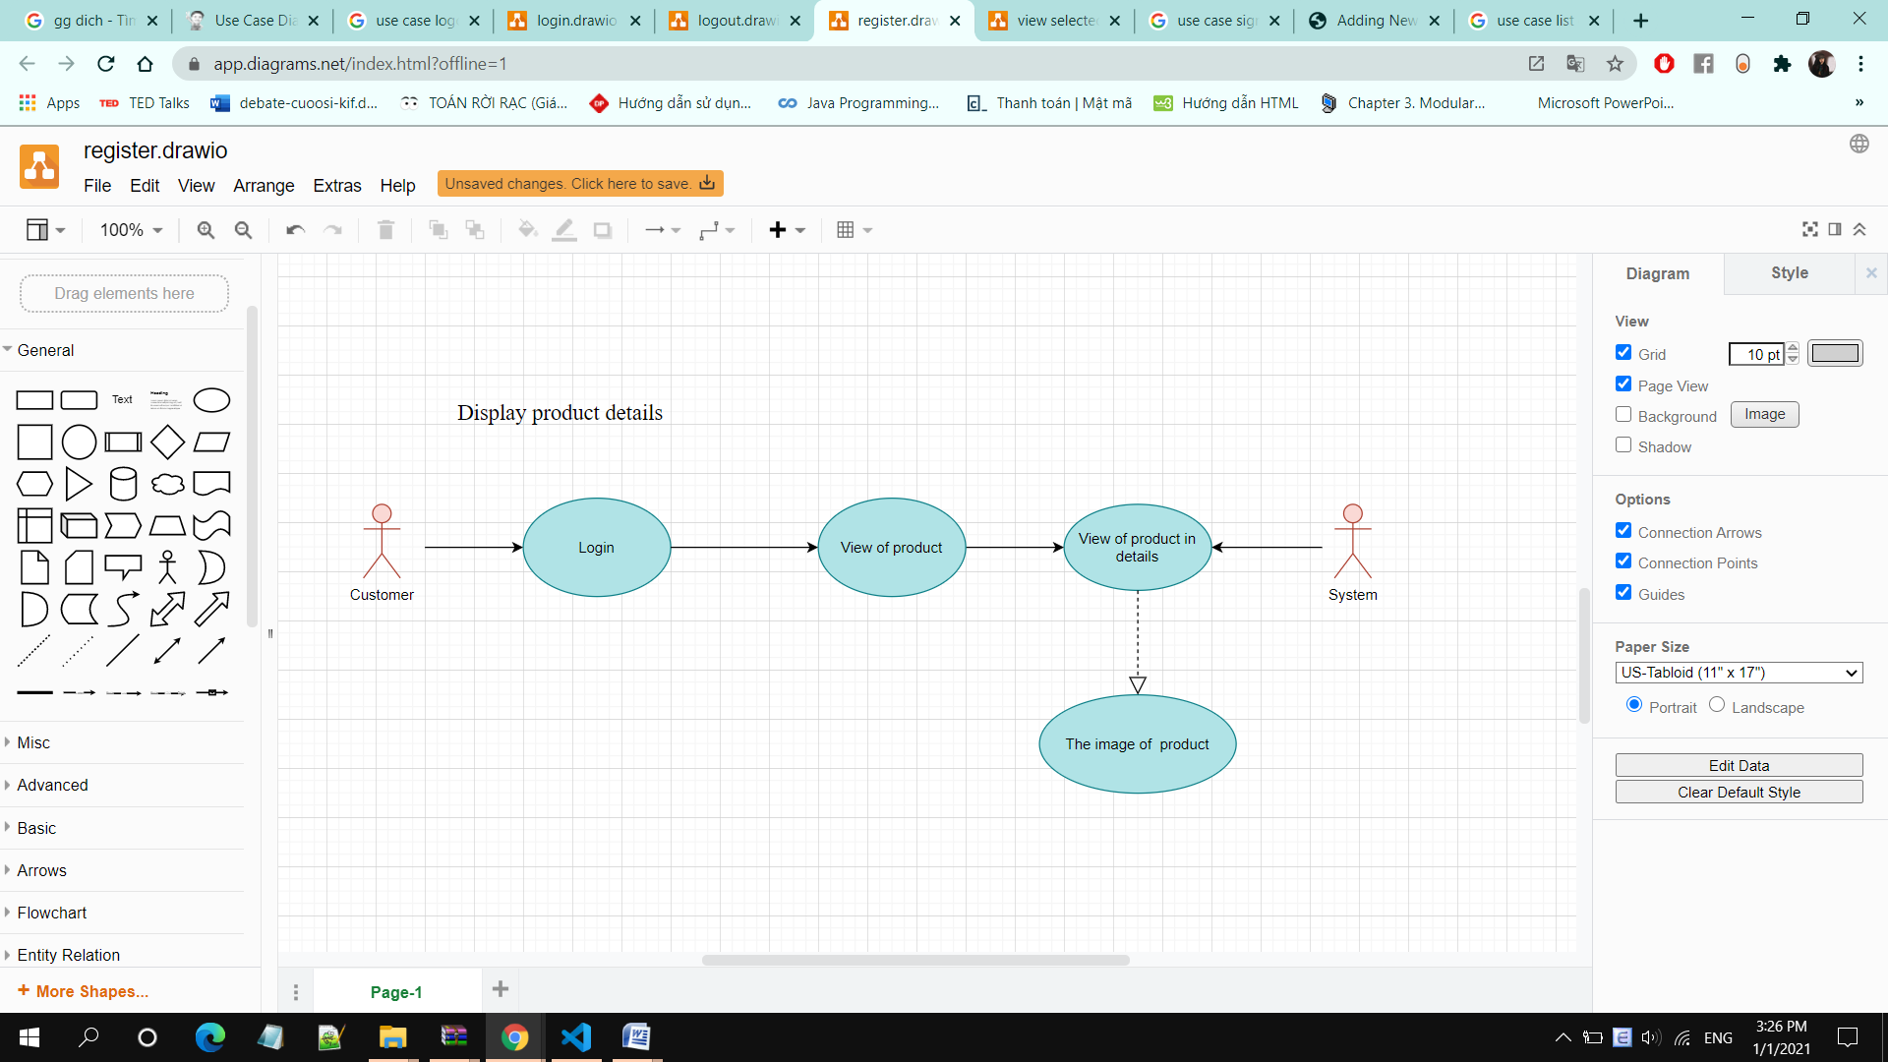

• **Brief Description:** A user displays detailed information of a product

• **Specification:** See Use-Case-Realization Specification: Display Product Detail

**Choose Product:**

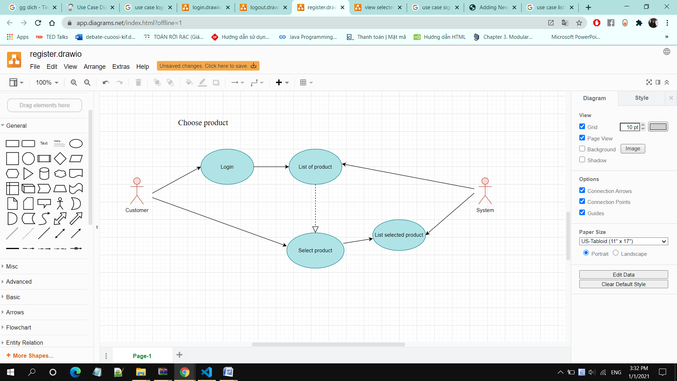

• **Brief Description:** A user chooses products based on search and/or filtering options.

• **Specification:** See Use-Case-Realization Specification: Choose Product

**Display Selected Product:**

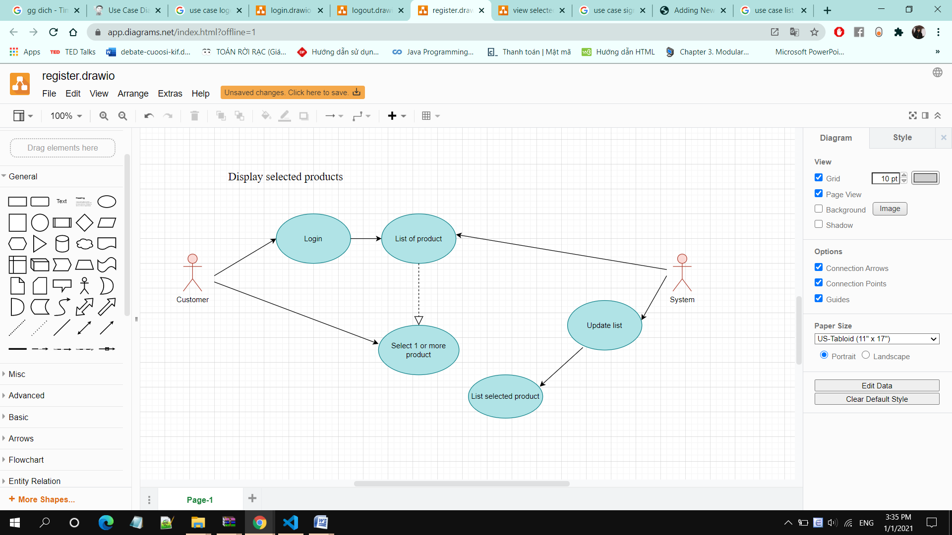

• **Brief Description:** A user displays list of selected products

• **Specification:** See Use-Case-Realization Specification: Display Selected Product

**Cancel Selected Product:**

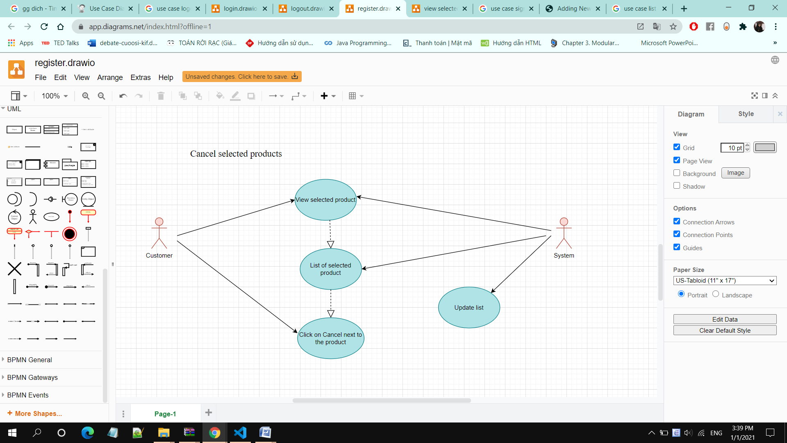

**• Brief Description:** A user unchecks the selected products

**• Specification:** See Use-Case-Realization Specification: Cancel Selected Product

**Order Product:**

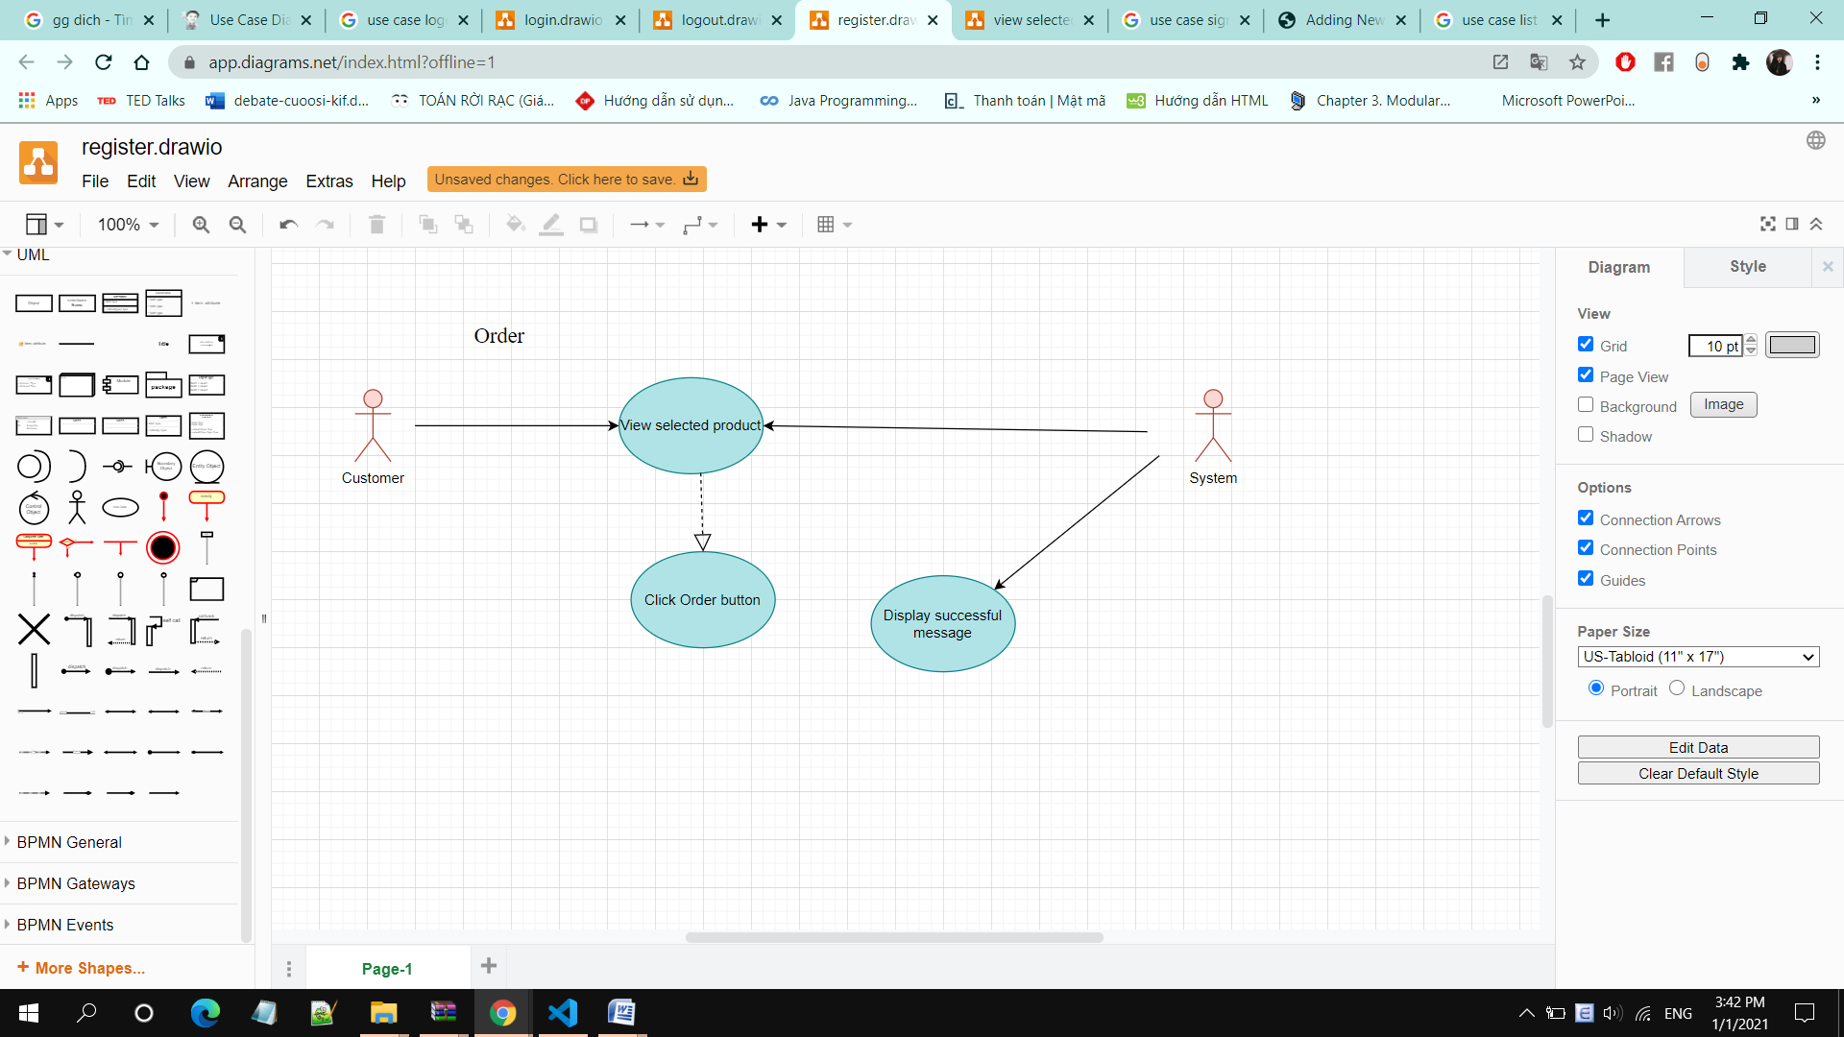

• **Brief Description:** A user orders the selected products online through the system

**• Specification:** See Use-Case-Realization Specification: Order Product

**Display Order Status:**

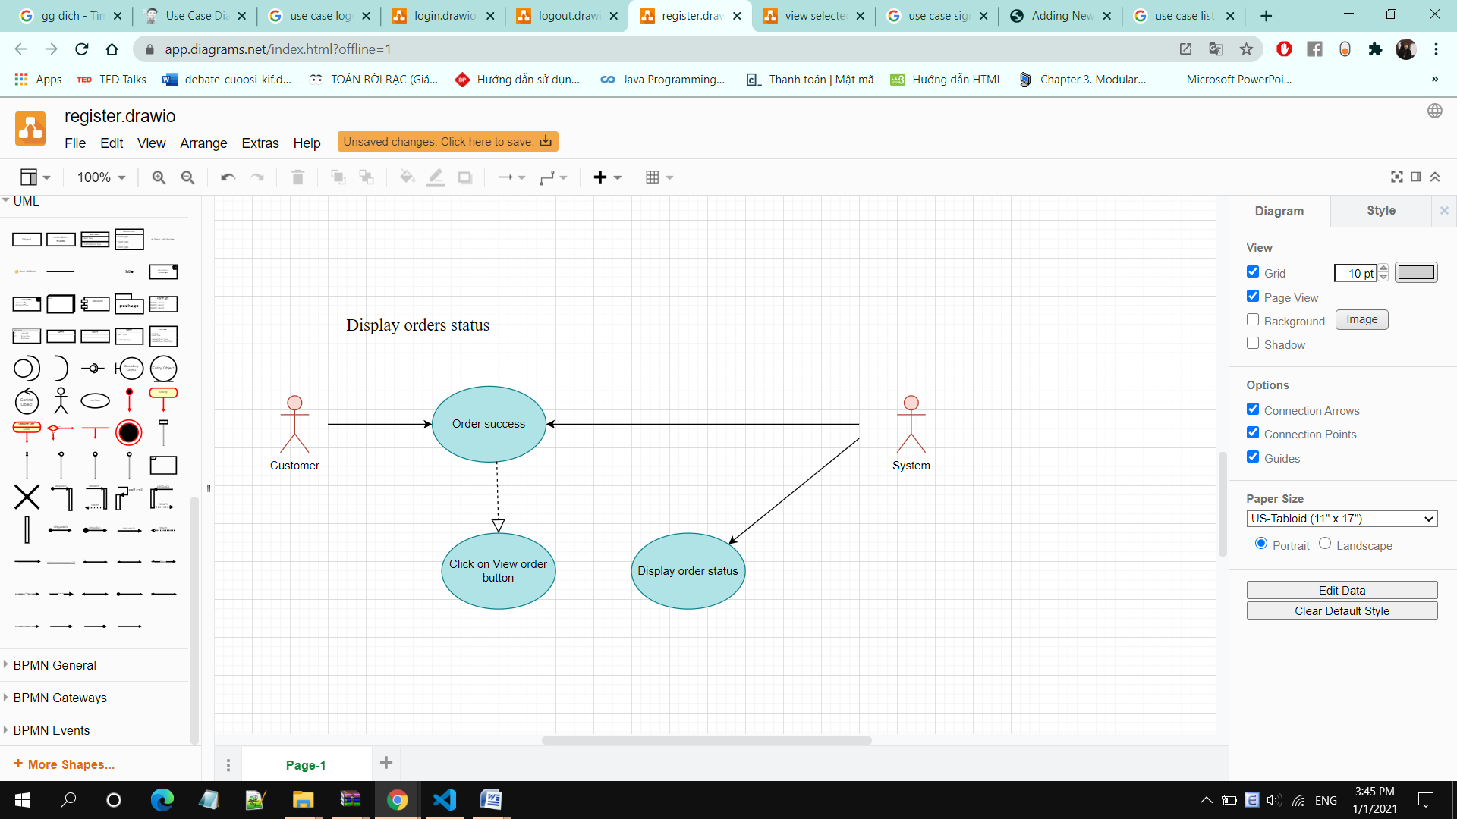

• **Brief Description:** A user displays order status after ordering

• **Specification:** See Use-Case-Realization Specification: Display Order Status

**Cancel Order:**

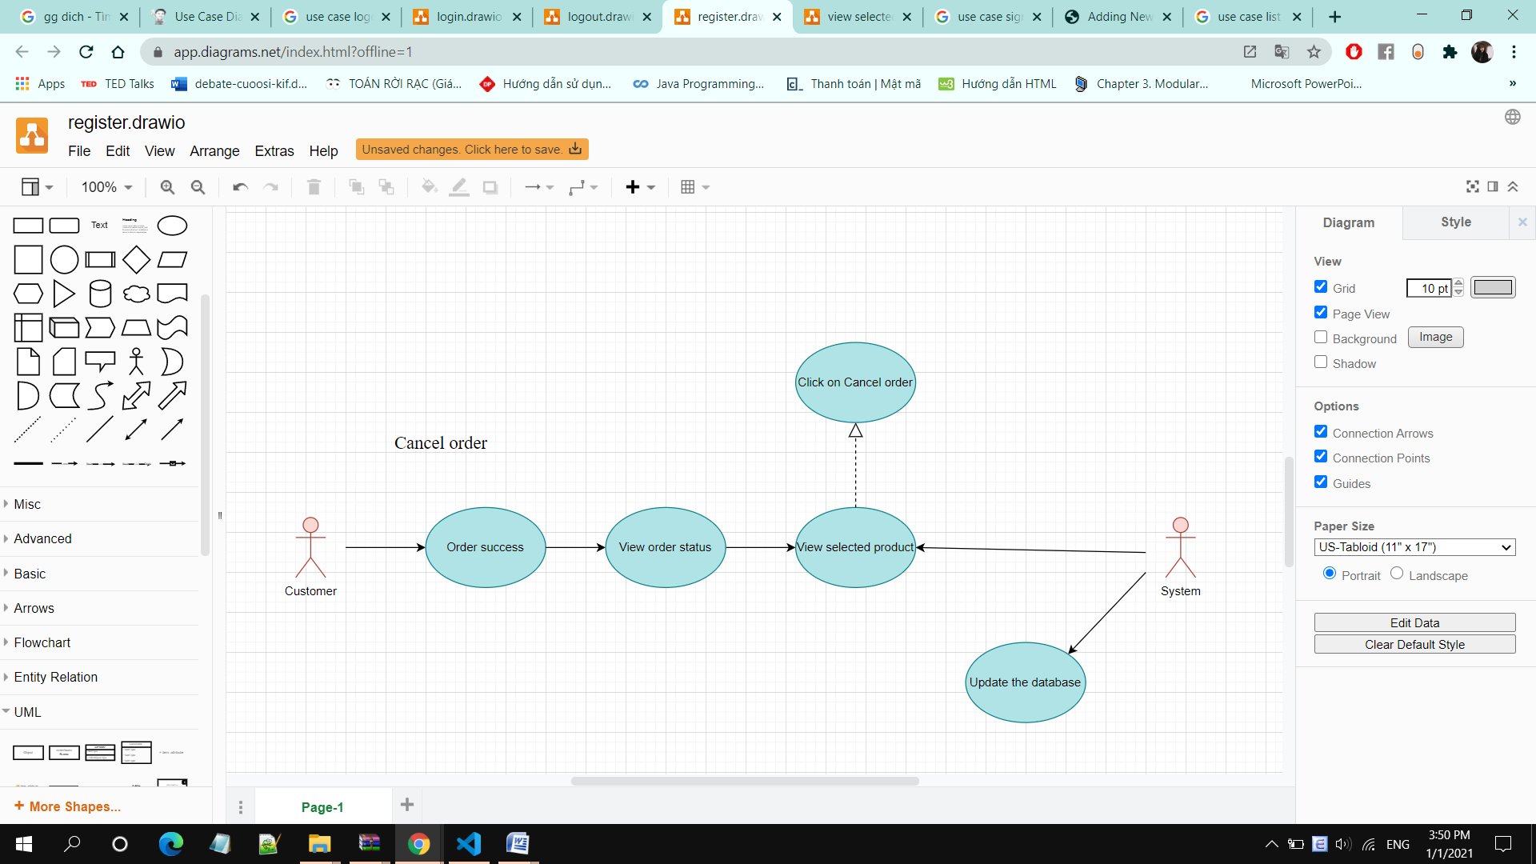

• **Brief Description:** A customer cancel purchase order.

• **Specification:** See Use-Case-Realization Specification: Cancel Order

**Add Product:**

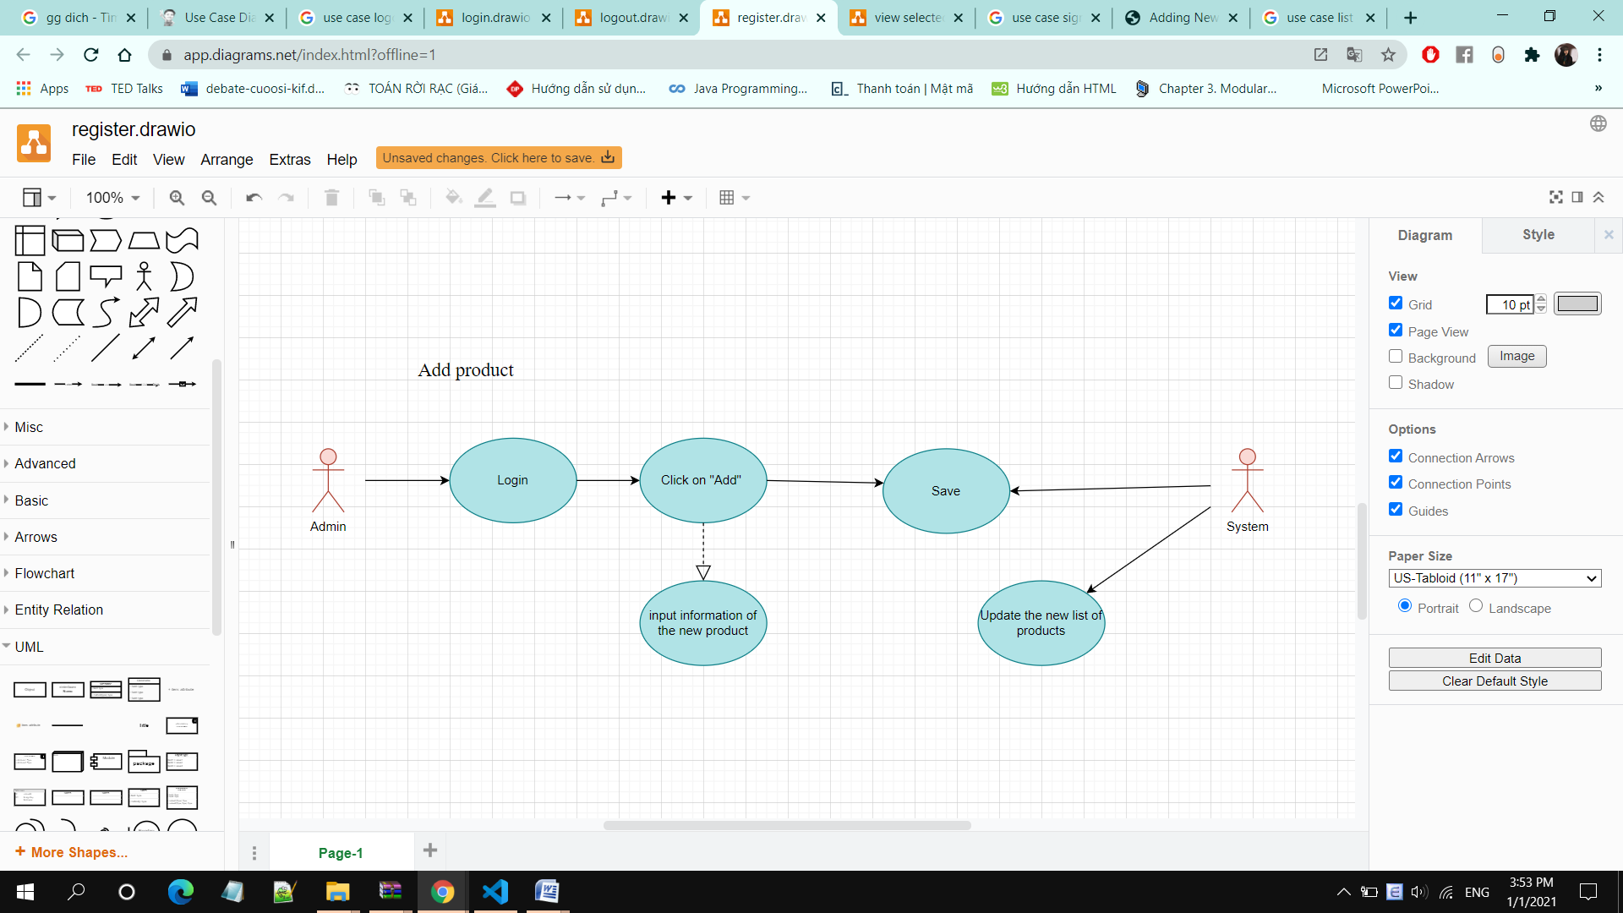

• **Brief Description:** Admin adds new product(s) to the database

• **Specification:** See Use-Case-Realization Specification: Add Product

**Edit Product:**

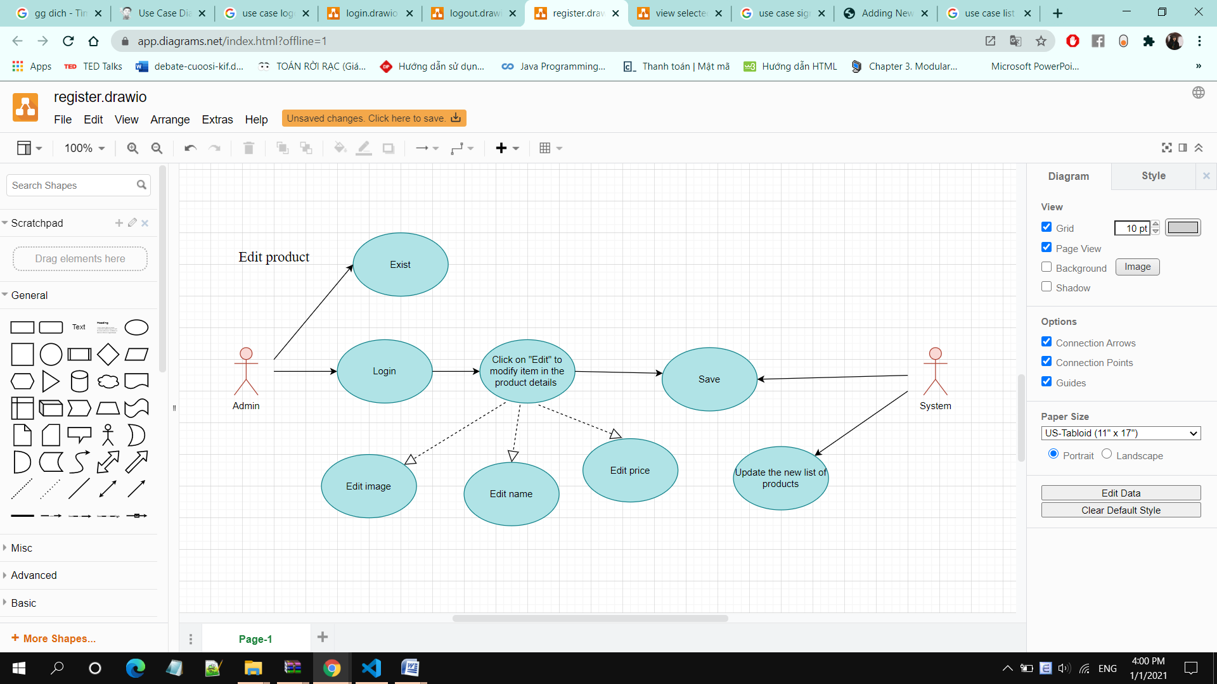

**• Brief Description:** Admin edits existing product(s) in the database

**• Specification:** See Use-Case-Realization Specification: Edit Product

**Delete Product:**

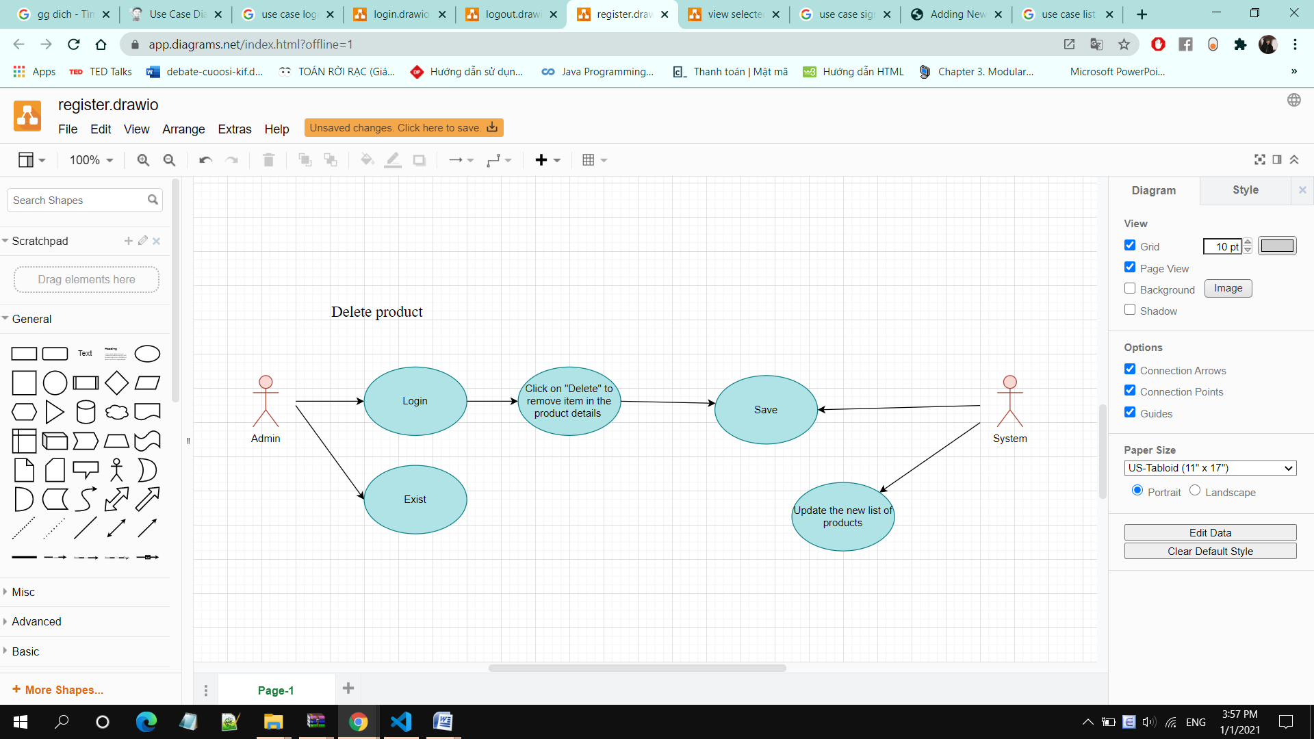

**• Brief Description:** Admin deletes product(s) from the database

**• Specification:** See Use-Case-Realization Specification: Delete Product

**Display Purchase Order:**

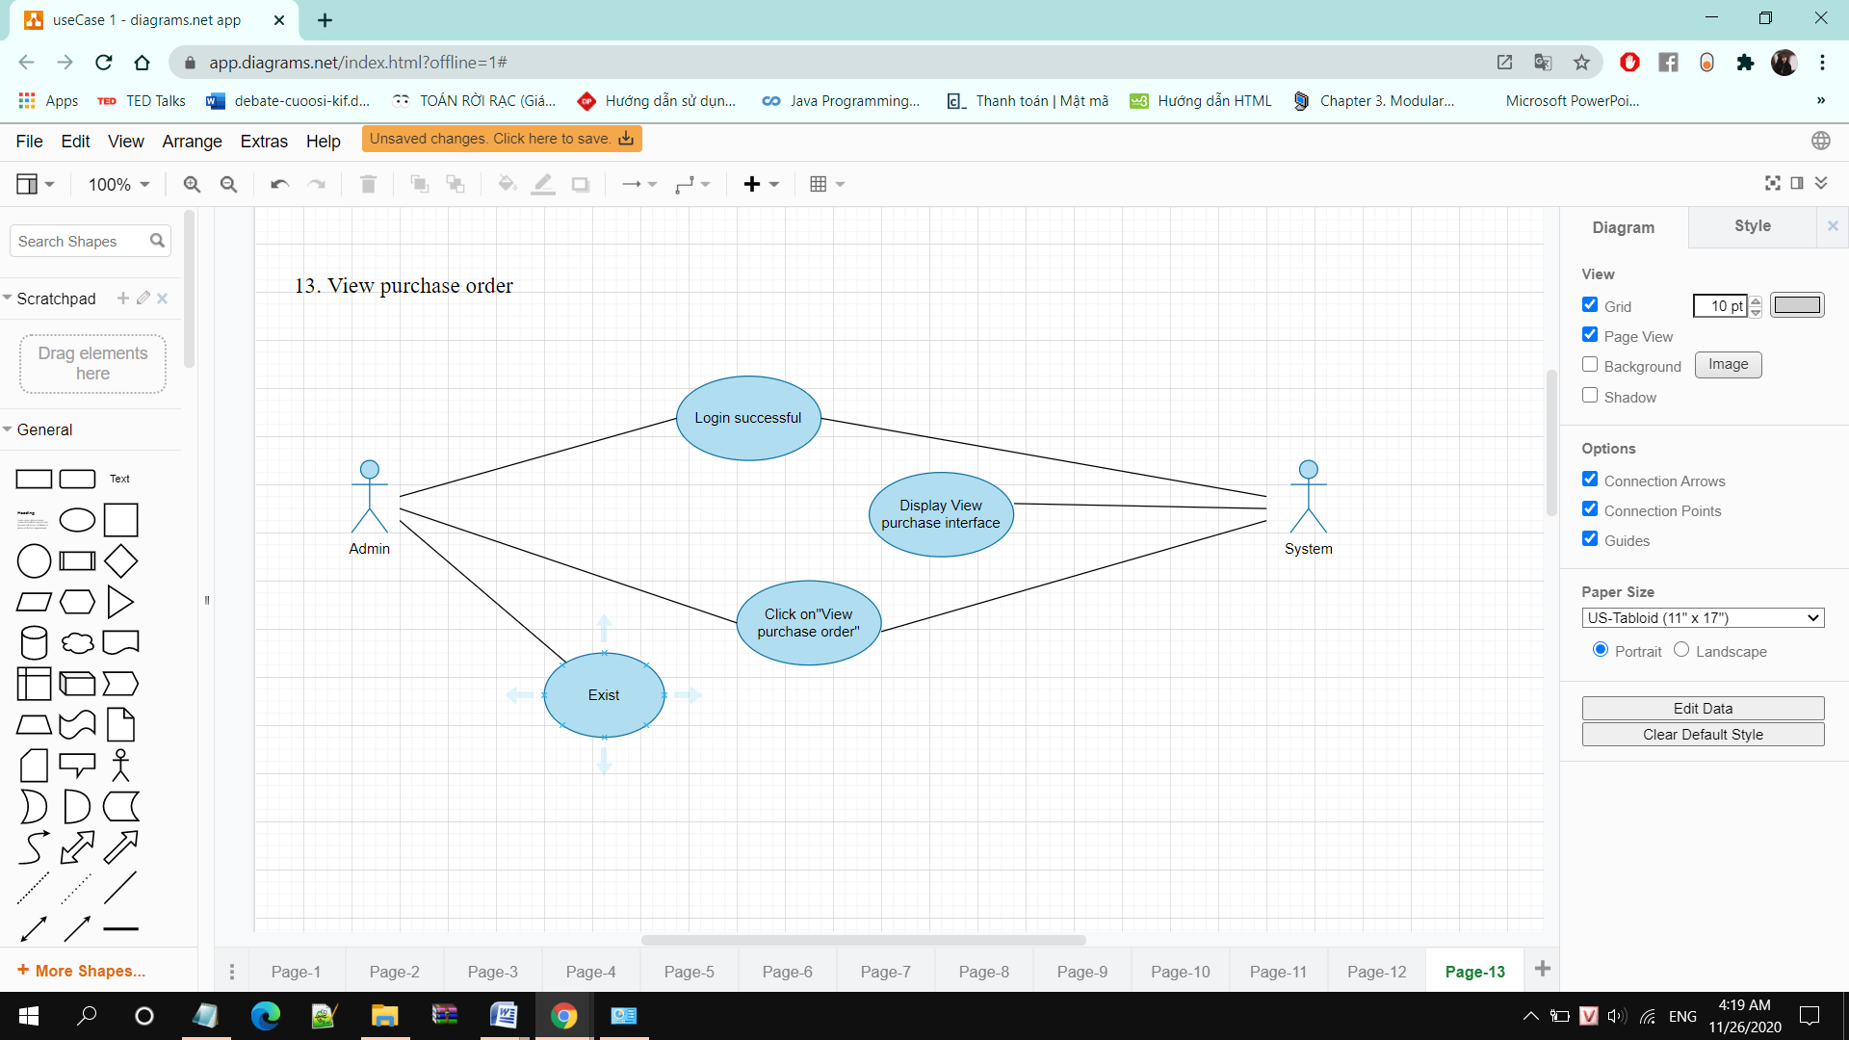

• **Brief Description:** Admin display the orders that have been ordered by customer

• **Specification:** See Use-Case-Realization Specification: Display Purchase Order

**Edit Order Status:**

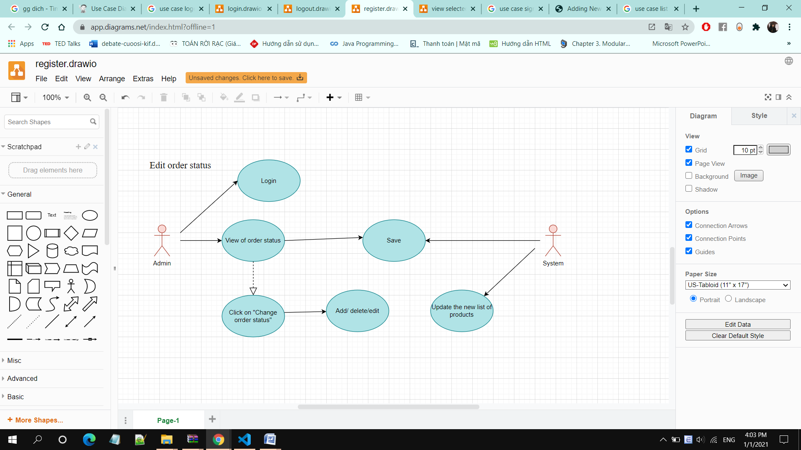

**• Brief Description:** Admin edits purchase order status in the system

• **Specification:** See Use-Case-Realization Specification: Edit Order Status